Activity S2H Area
👳🏻‍♀ Farmer Meeting👳🏻‍♀
RMO PATNA

Village: Rendia
District: Rohtash
Focused Crops- Paddy🌾🌾🌾🌾🌾

Farmer Meeting Addressed by:

1. Mr.Ashish Pratap singh( AMM Sasaram)

Participating Channel Partners:

1.Name:-Sukrit kssss
Proprietor Name :-chandan singh Mob:- 95760 60001
Location:- Indiagate.chenari

Attendance:
More than 40farmers participated in meeting.

Topics Discussed during the Farmer meeting:

1. Company profile, Vision
2. S2H Project and Our services and discussed about our products.
CPC :-Fillip,Mozo,Onvix,Lexon, Azole, etc.
SN :- Sulton, Superrhiza, Sulfino Gold, etc.
3. Importance of soil testing, balanced fertilizer usage, & its importance, and the importance and usage of Bio- Fertilizers etc.
4. Importance of Superrhiza, in Paddy crop.
5. Addressed general and technical queries of farmers and provided them precise solutions.

The meeting was organized by :
*Mr. Arunish kumar
*UKS Rohtash
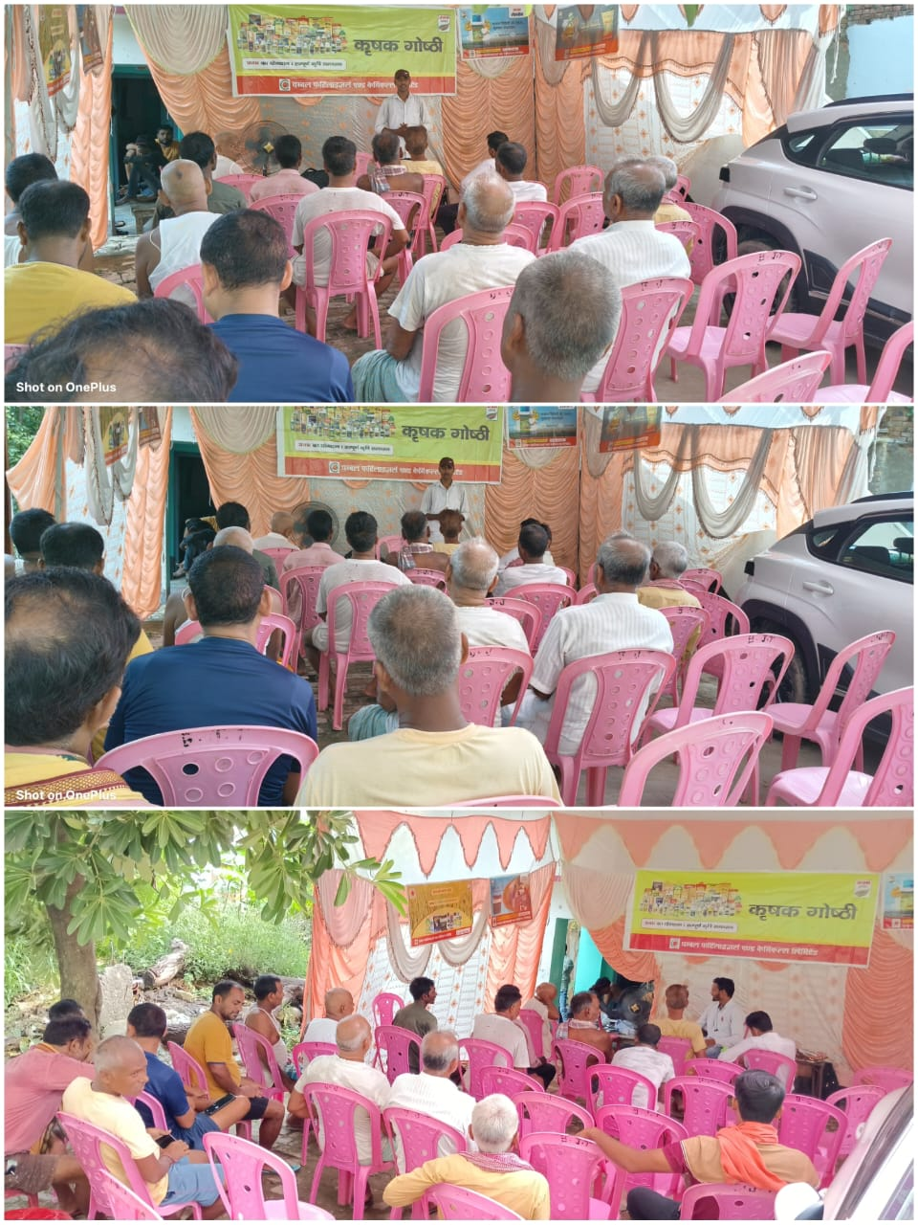

Activity S2H Area
👳🏻‍♀ Farmer Meeting👳🏻‍♀
RMO PATNA

Village: Tenduni
District: Rohtash
Focused Crops- Paddy🌾🌾🌾🌾🌾

Farmer Meeting Addressed by:

1. Mr.Ashish Pratap singh( AMM Sasaram)

Participating Channel Partners:

1.Name:-Sukrit kssss
Proprietor Name :-chandan singh Mob:- 95760 60001
Location:- Indiagate.chenari

Attendance:
More than 50farmers participated in meeting.

Topics Discussed during the Farmer meeting:

1. Company profile, Vision
2. S2H Project and Our services and discussed about our products.
CPC :-Fillip,Mozo,Onvix,Lexon, Azole, etc.
SN :- Sulton, Superrhiza, Sulfino Gold, etc.
3. Importance of soil testing, balanced fertilizer usage, & its importance, and the importance and usage of Bio- Fertilizers etc.
4. Importance of Superrhiza, in Paddy crop.
5. Addressed general and technical queries of farmers and provided them precise solutions.

The meeting was organized by :
*Mr. Arunish kumar
*UKS Rohtash Date:-10/09/2025
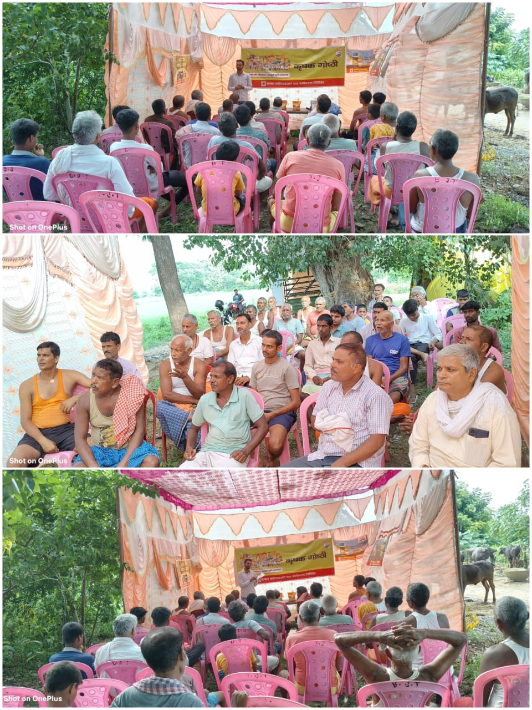

Activity S2H Area
👳🏻‍♀ Farmer Meeting👳🏻‍♀
RMO PATNA

Village: Shahpur
District: Rohtash
Focused Crops- Paddy🌾🌾🌾🌾🌾

Farmer Meeting Addressed by:

1. Mr.Ashish Pratap singh( Dmm sasaram)

Participating Channel Partners:

1. Name:- Sukrit kssss
Proprietor Name :-chandan singh
Mob:- 95760 60001
Location:- India gate chenari

Attendance:
More than 55 farmers participated in meeting.

Topics Discussed during the Farmer meeting:

1. Company profile, Vision
2. S2H Project and Our services and discussed about our products.
CPC :- Fillip, Mozo, veercombi-505, Onvix,Lexon, Azole, etc.

SN :- Sulton, Superrhiza, Sulfino Gold, Calrich etc.

3. Importance of soil testing, balanced fertilizer usage, & its importance, and the importance and usage of Bio- Fertilizers etc.
4. Importance of Superrhiza, in Paddy crop.
5. Addressed general and technical queries of farmers and provided them precise solutions.

The meeting was organized by :
*Mr. Arunish kumar
UKS Rohtash
